Task1:
import java.util.*;
public class Solution {
public static void main(String[] args) {
Scanner scanner = new Scanner(System.in);
int n = scanner.nextInt(); // size of the matrix
int[][] arr = new int[n][n];
for (int i = 0; i < n; i++) {
for (int j = 0; j < n; j++) {
arr[i][j] = scanner.nextInt();
}
}
int primaryDiagonal = 0;
int secondaryDiagonal = 0;
for (int i = 0; i < n; i++) {
primaryDiagonal += arr[i][i];
secondaryDiagonal += arr[i][n - 1 - i];
}
System.out.println(Math.abs(primaryDiagonal - secondaryDiagonal));
}
}
Output:
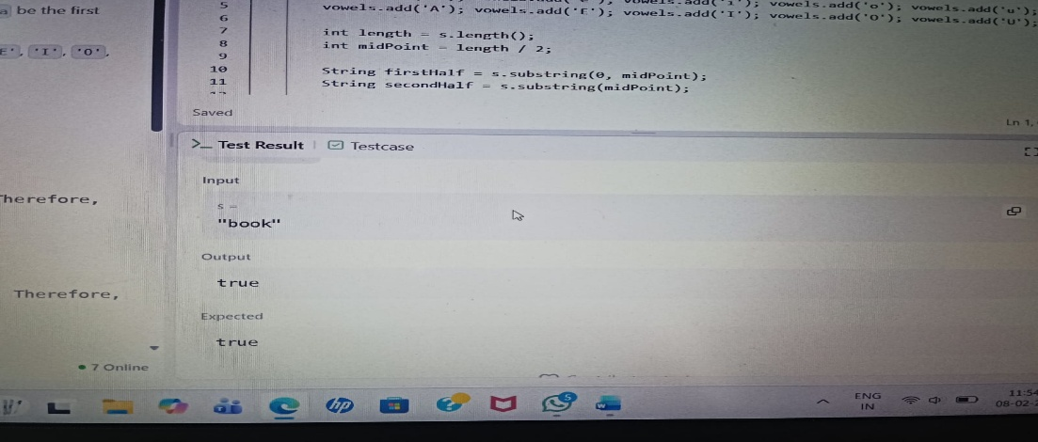

Task2:
import java.util.*;
import java.io.*;

class Lapindrome {
public static void main(String[] args) throws IOException {
BufferedReader br = new BufferedReader(new InputStreamReader(System.in));
int T = Integer.parseInt(br.readLine().trim());

while (T-- > 0) {
String s = br.readLine().trim();
int n = s.length();
String left, right;
if (n % 2 == 0) {
left = s.substring(0, n / 2);
right = s.substring(n / 2);
} else {
left = s.substring(0, n / 2);
right = s.substring(n / 2 + 1);
}
int[] freqLeft = new int[26];
int[] freqRight = new int[26];

for (char c : left.toCharArray()) {
freqLeft[c - 'a']++;
}
for (char c : right.toCharArray()) {
freqRight[c - 'a']++;
}
if (Arrays.equals(freqLeft, freqRight)) {
System.out.println("YES");
} else {
System.out.println("NO");
}
}
}
}
Output:
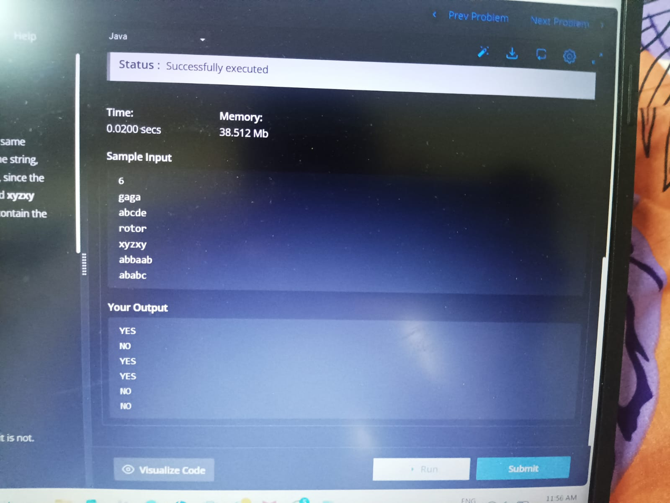

Task3:
import java.util.*;
public class Solution {
static List<Integer> compareTriplets(List<Integer> a, List<Integer> b) {
int aliceScore = 0;
int bobScore = 0;
for (int i = 0; i < 3; i++) {
if (a.get(i) > b.get(i)) {
aliceScore++;
} else if (a.get(i) < b.get(i)) {
bobScore++;
}
}
return Arrays.asList(aliceScore, bobScore);
}
public static void main(String[] args) {
Scanner sc = new Scanner(System.in);
List<Integer> a = new ArrayList<>();
List<Integer> b = new ArrayList<>();
for (int i = 0; i < 3; i++) {
a.add(sc.nextInt());
}
for (int i = 0; i < 3; i++) {
b.add(sc.nextInt());
}
List<Integer> result = compareTriplets(a, b);
System.out.println(result.get(0) + " " + result.get(1));
}
}

Output:
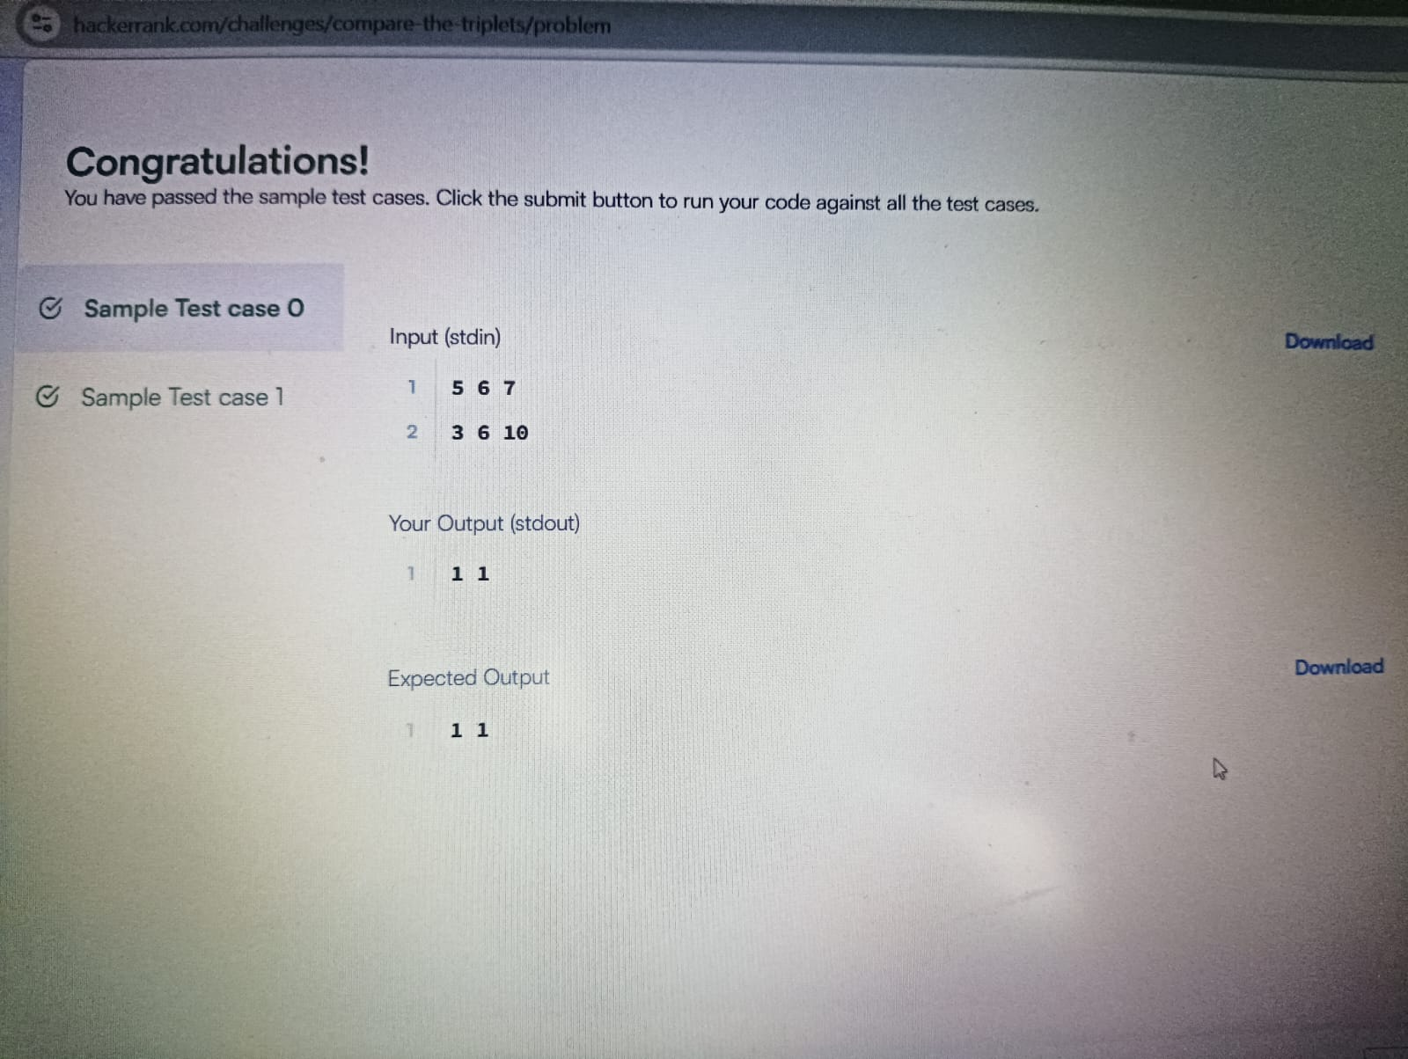

Task4:
class Solution {
public boolean containsDuplicate(int[] nums) {
Set<Integer> set = new HashSet<>();
for (int i : nums) {
if (set.contains(i)) {
return true;
} else {
set.add(i);
}
}
return false;
}
}

Output:
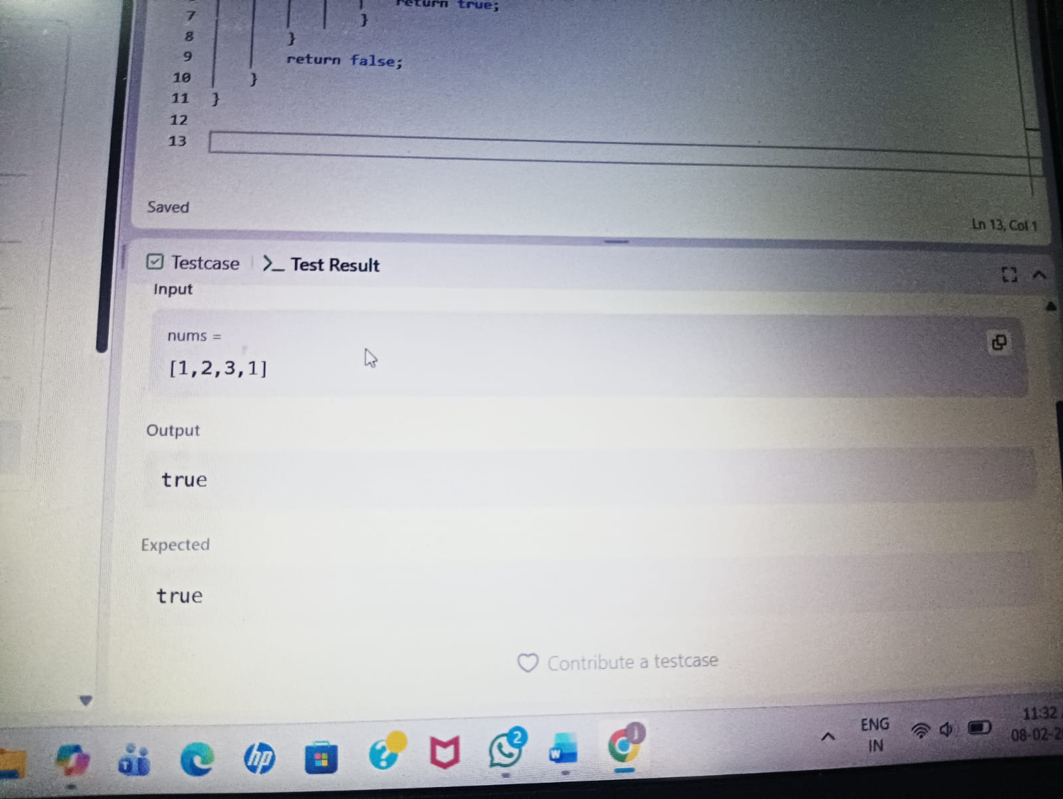

Task5:
import java.util.*;
import java.time.*;
import java.time.format.DateTimeFormatter;
public class Solution {
static String timeConversion(String s) {
DateTimeFormatter inputFormat = DateTimeFormatter.ofPattern("hh:mm:ssa")
DateTimeFormatter outputFormat = DateTimeFormatter.ofPattern("HH:mm:ss");
LocalTime time = LocalTime.parse(s, inputFormat);
return time.format(outputFormat);
}
public static void main(String[] args) {
Scanner sc = new Scanner(System.in);
String s = sc.nextLine();
String result = timeConversion(s);
System.out.println(result);
Output:
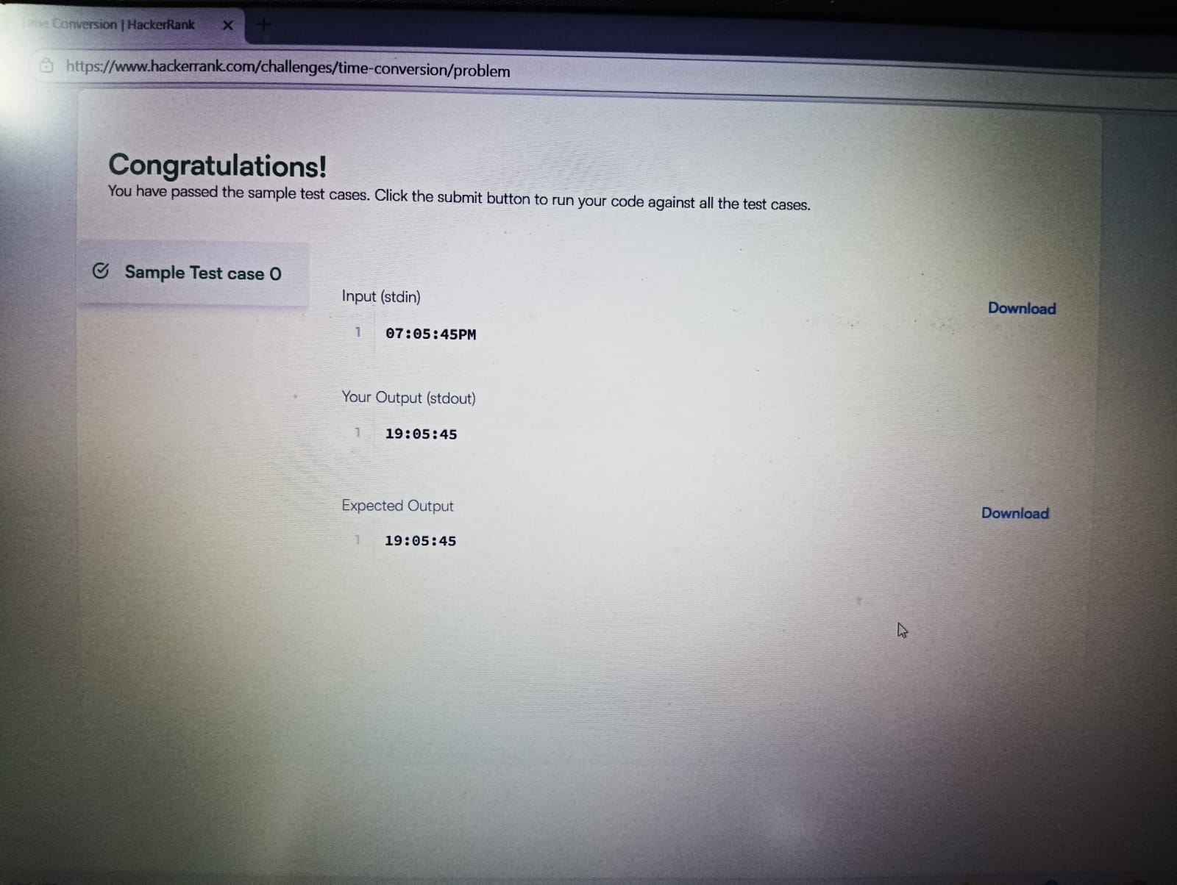

Task6:
class Solution {
public void moveZeroes(int[] nums) {
int x = 0;
for (int i = 0; i < nums.length; i++) {
if (nums[i] != 0) {
nums[x++] = nums[i];
}
}
while (x < nums.length) {
nums[x++] = 0;
}
}
}

Output:
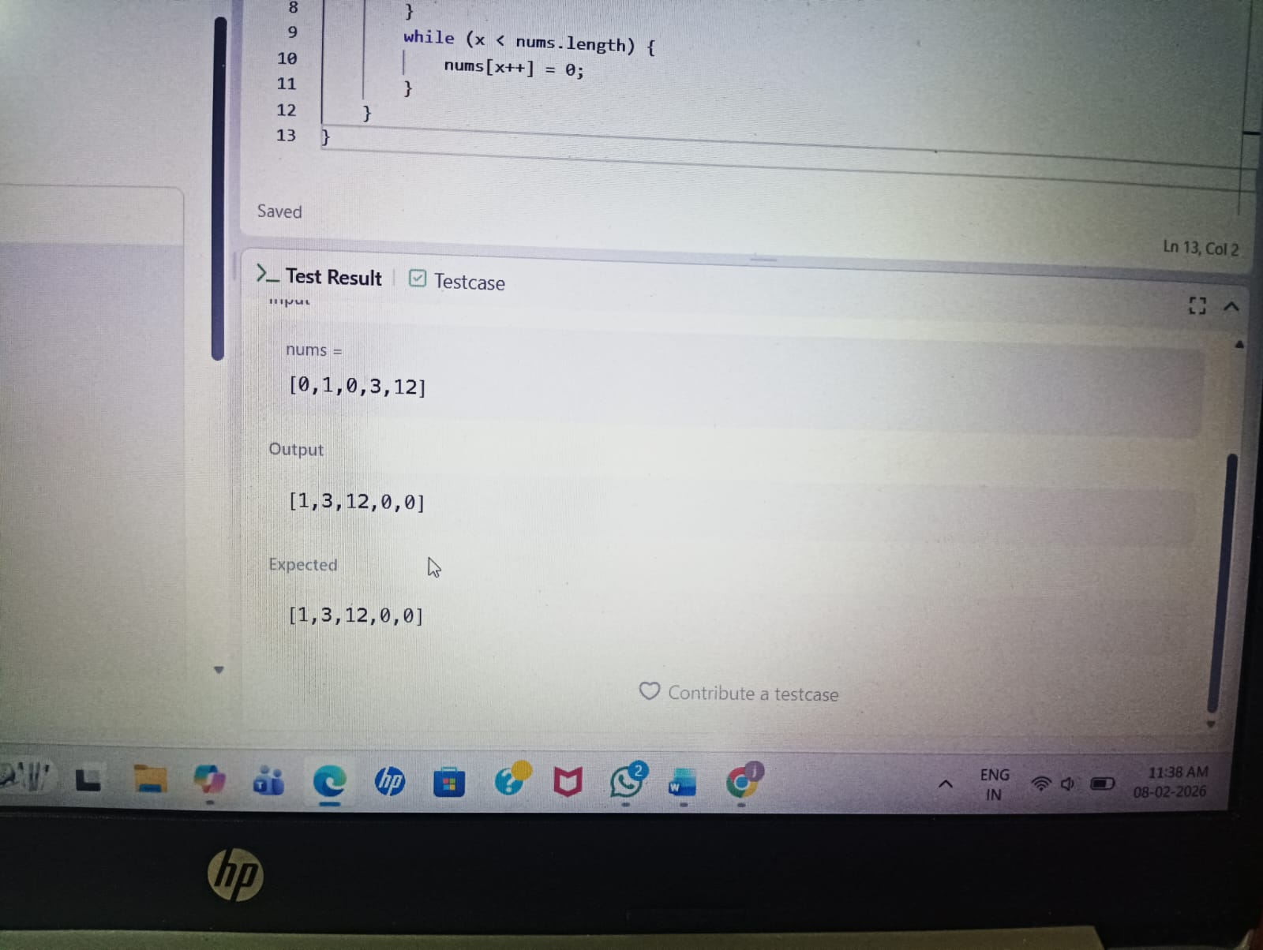

Task7:
import java.util.*;
public class Solution {
public static void main(String[] args) {
Scanner scanner = new Scanner(System.in);
int n = scanner.nextInt(); // size of the matrix
int[][] arr = new int[n][n];
for (int i = 0; i < n; i++) {
for (int j = 0; j < n; j++) {
arr[i][j] = scanner.nextInt();
}
}
int primaryDiagonal = 0;
int secondaryDiagonal = 0;
for (int i = 0; i < n; i++) {
primaryDiagonal += arr[i][i
secondaryDiagonal += arr[i][n - 1 - i];
}
System.out.println(Math.abs(primaryDiagonal - secondaryDiagonal));
}
}
Output:
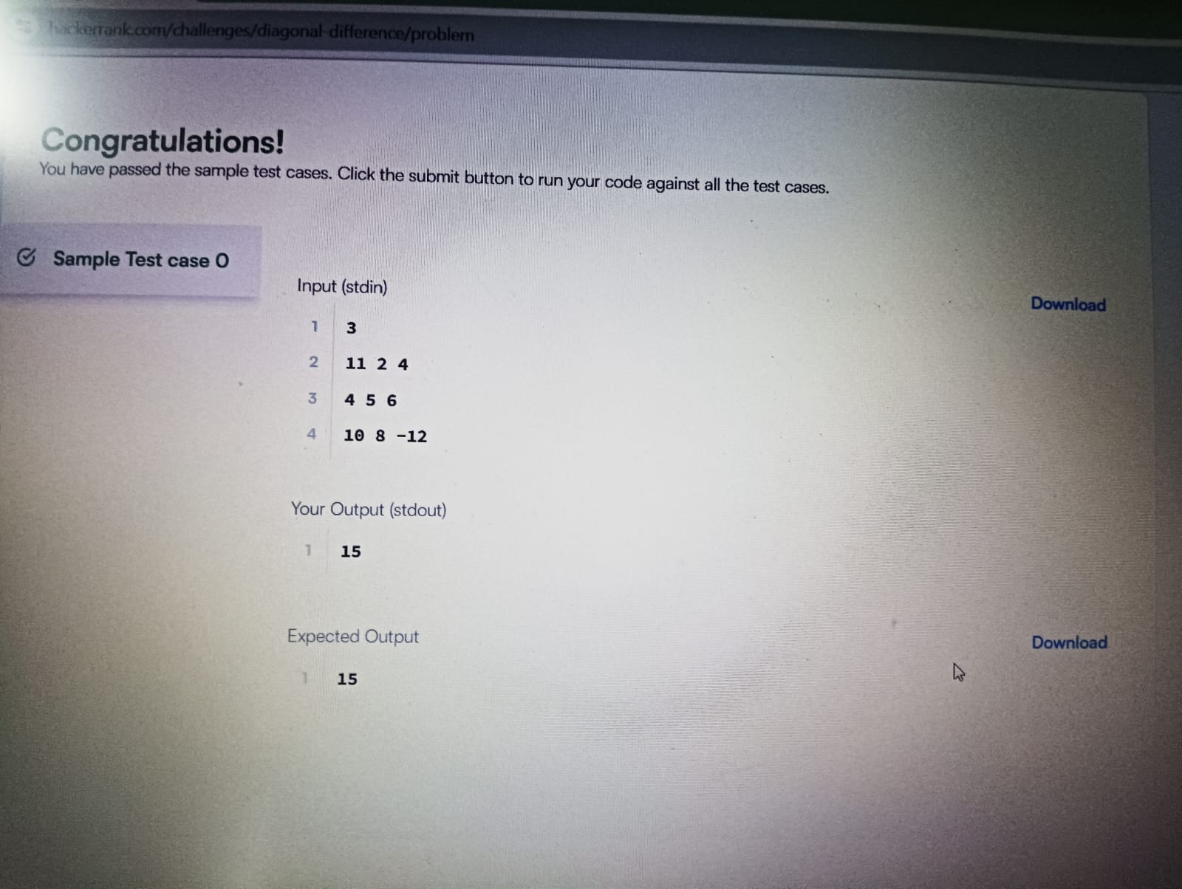
Task8:
class Solution {
public int[][] transpose(int[][] matrix) {
int n = matrix.length, m = matrix[0].length;
int[][] transposedMatrix = new int[m][n];
for (int i=0; i<m; i++)
for (int j=0; j<n; j++)
transposedMatrix[i][j] = matrix[j][i];
return transposedMatrix;
}
}

Output:
